**Add favorites**

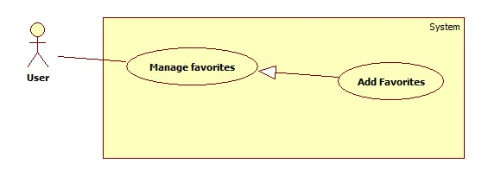

**Mobile version**

|  |  |  |  |
| --- | --- | --- | --- |
| **USE CASE – UU004** | | | |
| **Use Case No.** | UU004 | **Use Case Version** | 1.0 |
| **Use Case Name** | Add to favorite | | |
| **Author** | Bui Viet Phong | | |
| **Date** | 15/01/2014 | **Priority** | Normal |
| **Actor:** User  **Summary:**  This user case allow user to add a traffic sign into favorite list.  **Goal:**  Add a traffic sign into favorite list.  **Triggers:**   * In our system, each user has a favorite list to bookmark traffic signs for viewing later again. * To add a traffic sign into favorite list, user must: * View traffic sign details by auto search or manually search. * On the traffic sign details screen, select favorite item.   **Preconditions:**   * Guest must log in the system. * The traffic sign is not added into favorite list before.   **Post Conditions:**   * **Success:** The popup inform that the traffic sign has been added to favorite list * **Fail:** No traffic sign has been added to favorite list.   **Main Success Scenario:**   |  |  |  | | --- | --- | --- | | Step | Actor Action | System Response | | 1 | - Choose ‘Tra cứu biển báo’  - Choose one item in category.  [Alternative 1] | Show the list of traffic signs in the category which was chosen by user before. | | 2 | Choose one traffic sign in the list.  [Alternative 1] | Show the Traffic details screen, contains detail of traffic sign, include:   * Traffic sign Image * Traffic sign content * Penalize fee. | | 3 | Click on favorite item at the top-right corner of the screen. | Add the traffic sign to favorite list and show the message:  “Biển báo đã được thêm vào danh sách yêu thích” |   **Alternative Scenario:**   |  |  |  | | --- | --- | --- | | No | Actor Action | System Response | | 1 | [Alternative 1]  View a traffic sign by search auto on mobile in use case **ABC** |  |   **Exceptions:** N/A  **Relationships:** Manage favorite  **Business Rules:** N/A | | | |

**Web version**

|  |  |  |  |
| --- | --- | --- | --- |
| **USE CASE – UU004** | | | |
| **Use Case No.** | UU004 | **Use Case Version** | 1.0 |
| **Use Case Name** | Add to favorite | | |
| **Author** | Bui Viet Phong | | |
| **Date** | 15/01/2014 | **Priority** | Normal |
| **Actor:** User  **Summary:**  This user case allow user to add a traffic sign into favorite list.  **Goal:**  Add a traffic sign into favorite list.  **Triggers:**   * In our system, each user has a favorite list to bookmark traffic signs for viewing later again. * To add a traffic sign into favorite list, user must: * View traffic sign details by auto search or manually search. * On the traffic sign details screen, click button “Thêm vào danh sách yêu thích”.   **Preconditions:**   * Guest must log in the system. * The traffic sign is not added into favorite list before.   **Post Conditions:**   * **Success:** The popup inform that the traffic sign has been added to favorite list * **Fail:** No traffic sign has been added to favorite list.   **Main Success Scenario:**   |  |  |  | | --- | --- | --- | | Step | Actor Action | System Response | | 1 | - Click one type off traffic sign in category  [Alternative 1] [Alternative 2] | Show the list of traffic signs in the category which was chosen by user. | | 2 | Click on one traffic sign in the list.  [Alternative 2] | Show the Traffic details screen, contains detail of traffic sign, include:   * Traffic sign Image * Traffic sign content * Penalize fee. | | 3 | Click button “Thêm vào danh sách yêu thích” | Add the traffic sign to favorite list and show the notice with message:  “Biển báo đã được thêm vào danh sách yêu thích” |   **Alternative Scenario:**   |  |  |  | | --- | --- | --- | | No | Actor Action | System Response | | 1 | Enter traffic sign’s name then click “Tìm kiếm” | Show the list of traffic signs have name match with key words. | | 2 | View a traffic sign by search auto on web in use case **ABC** |  |   **Exceptions:** N/A  **Relationships:** Manage favorite  **Business Rules:** N/A | | | |

**Remove favorites**

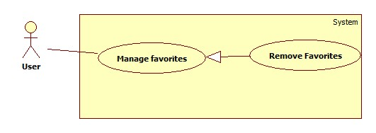

**Mobile version**

|  |  |  |  |
| --- | --- | --- | --- |
| **USE CASE – UU005** | | | |
| **Use Case No.** | UU005 | **Use Case Version** | 1.0 |
| **Use Case Name** | Remove from favorite list | | |
| **Author** | Bui Viet Phong | | |
| **Date** | 15/01/2014 | **Priority** | Normal |
| **Actor:** User  **Summary:**  This user case allow user to remove a traffic sign from favorite list.  **Goal:**  Remove a traffic sign from favorite list**.**  **Triggers:**   * In our system, each user has a favorite list to bookmark traffic signs for viewing later again. * To remove a traffic sign from favorite list, user must: * Select ‘Danh sách yêu thích’ to view favorite list. * Select and hold on the traffic sign for 1 second. * Select ‘Xóa’.   **Preconditions:**   * Guest must logged in the system.   **Post Conditions:**   * **Success:** The traffic sign has been remove from favorite list. * **Fail:** No traffic signs has been remove from favorite list.   **Main Success Scenario:**   |  |  |  | | --- | --- | --- | | Step | Actor Action | System Response | | 1 | - Click ‘Danh sách yêu thích’  [Alternative 1] | Show the list of traffic signs in the favorite list. | | 2 | Select and hold on one traffic sign in the list for 1 second.  [Alternative 1] | Show the menu, contains below items:   * Chuyển lên trên * Chuyển xuống dưới * Xóa | | 3 | Select ‘Xóa’  [Alternative 1] | Remove the traffic sign from favorite list. |   **Alternative 1:**   |  |  |  | | --- | --- | --- | | Step | Actor Action | System Response | | 1 | - View a traffic sign by search auto or by search manually on mobile in use case **ABC** – |  | | 2 | Select the “Yellow star” on the top-right screen | Remove the traffic sign from favorite list. |   **Exceptions:** N/A  **Relationships:** Manage favorite  **Business Rules:** N/A | | | |

**Web version**

|  |  |  |  |
| --- | --- | --- | --- |
| **USE CASE – UU005** | | | |
| **Use Case No.** | UU005 | **Use Case Version** | 1.0 |
| **Use Case Name** | Remove from favorite list | | |
| **Author** | Bui Viet Phong | | |
| **Date** | 15/01/2014 | **Priority** | Normal |
| **Actor:** User  **Summary:**  This user case allow user to remove a traffic sign from favorite list.  **Goal:**  Remove a traffic sign from favorite list**.**  **Triggers:**   * In our system, each user has a favorite list to bookmark traffic signs for viewing later again. * To remove a traffic sign from favorite list, user must: * Select ‘Danh sách yêu thích’ to view favorite list. * Select ‘Xóa’.   **Preconditions:**   * Guest must logged in the system.   **Post Conditions:**   * **Success:** The traffic sign has been remove from favorite list. * **Fail:** No traffic signs has been remove from favorite list.   **Main Success Scenario:**   |  |  |  | | --- | --- | --- | | Step | Actor Action | System Response | | 1 | - Click ‘Danh sách yêu thích’ | Redirect to favorite page, include:   * List of traffic signs in the favorite list. * Button “Xóa” | | 2 | Click button “Xóa” in the row contain the traffic | Remove the traffic sign from favorite list. |   **Alternative Scenario:** N/A  **Exceptions:** N/A  **Relationships:** Manage favorite  **Business Rules:** N/A | | | |

**ImportFromfile (đề xuất sửa thành import Traffic sign from file)**

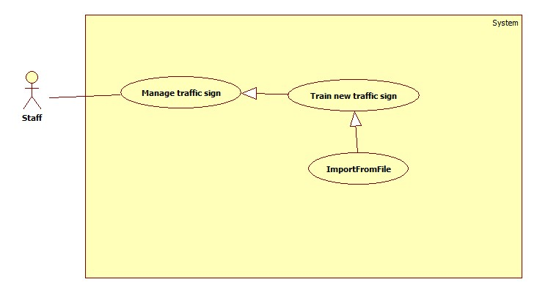

|  |  |  |  |
| --- | --- | --- | --- |
| **USE CASE – AD007** | | | |
| **Use Case No.** | AD007 | **Use Case Version** | 1.0 |
| **Use Case Name** | Import traffic sign from file | | |
| **Author** | Bui Viet Phong | | |
| **Date** | 15/01/2014 | **Priority** | Normal |
| **Actor:** Staff  **Summary:**  This user case allow staff to train new traffic signs from existing file.  **Goal:**  Train new traffic signs from existing file**.**  **Triggers:**   * For recognize or view traffic signs details, the system must store traffic signs information and images for recognition. * To train new traffic signs from existing file, staff must: * Select ‘Quản lý biển báo’ * Click “Thêm biển báo từ tập tin” * Select file to upload then click “Tải lên”.   **Preconditions:**   * Guest must logged in the system with role staff. * Staff has the file to upload.   **Post Conditions:**   * **Success:** The new traffic signs has been added to database. * **Fail:** No traffic signs has been has been added to database.   **Main Success Scenario:**   |  |  |  | | --- | --- | --- | | Step | Actor Action | System Response | | 1 | - Click ‘Quản lý biển báo’ | Redirect to Traffic management page, contains:   * List of the current traffic signs. * “Tạo mới biển báo” button. * “Thêm biển báo từ tập tin” button * “Chỉnh sửa” button | | 2 | Click “Thêm biển báo từ tập tin” button | Redirect to Import traffic sign page, contains:   * File Upload Control. * “Tải lên” button. * “Hủy” button | | 3 | Select file to upload from File Upload Control then click “Tải lên” button.  [Alternative 1] | Upload file and add new traffic signs to database.  Redirect to Traffic management page. |   **Alternative Scenario:**   |  |  |  | | --- | --- | --- | | No | Actor Action | System Response | | 1 | [Alternative 1]  - Click “Hủy” button | Redirect to Traffic management page. |   **Exceptions:**   |  |  |  | | --- | --- | --- | | No | Actor Action | System Response | | 1 | Not select file, click “Tải lên” button | Display error message: “Vui lòng chọn file để tải lên” | | 2 | Upload wrong file. | Display error message: “ Tập tin không đúng định dạng” |   **Relationships:** Manage traffic signs  **Business Rules:** N/A | | | |

**EDIT TRAFFIC SIGN**

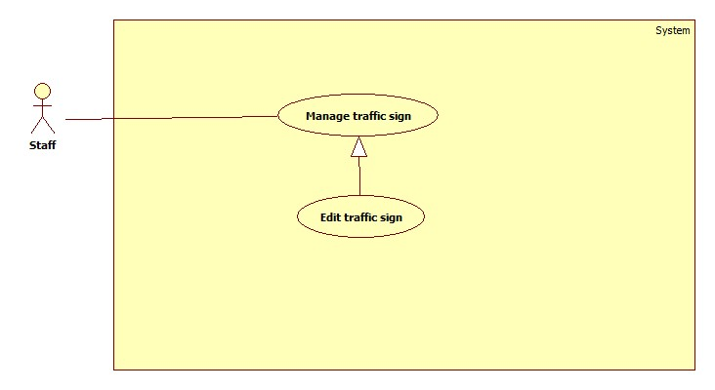

|  |  |  |  |
| --- | --- | --- | --- |
| **USE CASE – AD007** | | | |
| **Use Case No.** | AD007 | **Use Case Version** | 1.0 |
| **Use Case Name** | Edit traffic sign | | |
| **Author** | Bui Viet Phong | | |
| **Date** | 15/01/2014 | **Priority** | Normal |
| **Actor:** Staff  **Summary:**  This user case allow staff to edit traffic sign information or traffic images.  **Goal:**  Edit traffic sign information or traffic images**.**  **Triggers:**   * For recognize or view traffic signs details, the system must store traffic signs information and images for recognition. * To edit traffic signs, staff must: * Select ‘Quản lý biển báo’ * Click “Chỉnh sửa” * Edit information or add image then click “Hoàn tất”.   **Preconditions:**   * Guest must logged in the system with role staff.   **Post Conditions:**   * **Success:** The new traffic sign’s information or image will be updated. * **Fail: T**raffic sign’s information or image will not be updated.   **Main Success Scenario:**   |  |  |  | | --- | --- | --- | | Step | Actor Action | System Response | | 1 | - Click ‘Quản lý biển báo’ | Redirect to Traffic management page, contains:   * List of the current traffic signs. * “Tạo mới biển báo” button. * “Thêm biển báo từ tập tin” button * “Chỉnh sửa” button | | 2 | Click “Chỉnh sửa” button | Redirect to edit traffic sign page, contains:   * Text filed: All about traffic sign information. * File Upload Control. * “Hoàn tất” button. * “Hủy” button | | 3 | Edit information in text box or select file to upload from File Upload Control to add more image then click “Hoàn tất”.  [Alternative 1] | Update traffic sign information or images.  Redirect to Traffic management page. |   **Alternative Scenario:**   |  |  |  | | --- | --- | --- | | No | Actor Action | System Response | | 1 | [Alternative 1]  - Click “Hủy” button | Redirect to Traffic management page. |   **Exceptions:**   |  |  |  | | --- | --- | --- | | No | Actor Action | System Response | | 1 | Select wrong file. | Display error message: “ Tập tin không đúng định dạng” |   **Relationships:** Manage traffic signs  **Business Rules:** N/A | | | |